1. **SELECT `student`.*, `group`.`number` FROM `student`**

**inner joiN `group`**

**on `student`.`groupId` = `group`.`Id`**

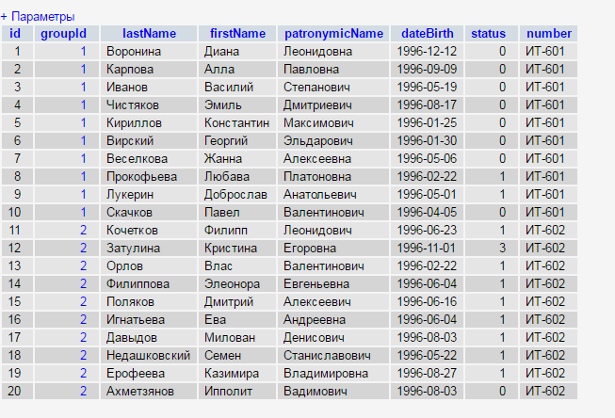

1. **SELECT `student`.`lastName`, `subject`.`name`, `mark`.`value` FROM `mark`**

**inner join `student` on `student`.`id`=`mark`.`studentId`**

**inner join `course` on `mark`.`courseId`=`course`.`id`**

**inner join `subject` on `subject`.`id`=`course`.`subjectId`**

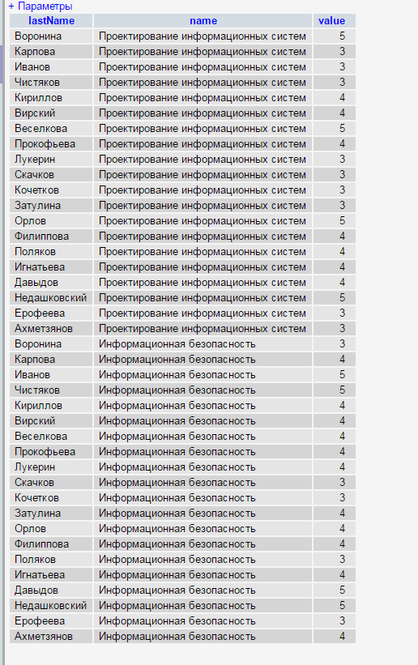

1. **SELECT `teacher`.`lastName`, `subject`.`name` FROM `course`**

**inner join `subject` on `course`.`subjectId`=`subject`.`id`**

**inner join `teacher` on `course`.`teacherId`=`teacher`.`id`**

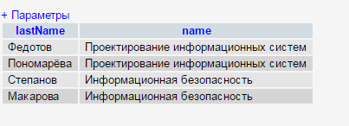

1. **SELECT student.lastName as monitorlastName FROM `student`**

**inner join `group` on `group`.`id`=`student`.`groupId`**

**inner join student as `monitor` on `group`.`monitorId`=`monitor`.`id`**

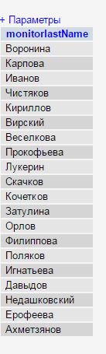

1. **SELECT `group`.`number` , monitor.lastName FROM `group`**

**left join student as monitor on `group`.`monitorId`=`monitor`.`id`**

